Southwest University
School of Computer & Information Science
Database Principles and Applications
Course Design Report

Coffee Shop Order Management System

Team Members :
114 Yang Fan (Team Leader)
092 Xu Yueqian
Major : Computer Science and Technology, Class of 2024
Course : Database Principles and Applications
Date : May 2026

Table of Contents

1. Division of Labor 1
1.1 Team Composition 1
1.2 Responsibility Matrix 1
1.3 Collaboration Workflow 2

2. Overview 2
2.1 Project Background 2
2.2 Main Tasks of the Project 2
2.3 Key Problems to Solve 3

3. Database Design and SQL Statements 3
3.1 Requirement Analysis 3
3.2 Conceptual Design (ER Model) 4
3.3 Logical Design (Relations) 4
3.4 Physical Design (MySQL DDL) 5
3.5 Constraints and Business Rules 5
3.6 Database Programming (Triggers + Stored Procedure) 6
3.7 Representative SQL Queries 7
3.8 Sample DML for Testing 7

4. Brief Instructions for Use 8
4.1 Environment Prerequisites 8
4.2 One-click Launch (macOS / Windows) 8
4.3 Manual Launch and MySQL Setup 8
4.4 Demo Accounts 9
4.5 Typical User Workflow 9

5. Main Interface Screenshots 9
Figure 2. Dashboard 9
Figure 3. Menu Page 10
Figure 4. New Order Page 10
Figure 5. Order List 11
Figure 6. Statistics Page 11

6. Summary 12
6.1 What We Accomplished 12
6.2 Existing Problems and Improvements 12
6.3 Learning Outcomes 13

7. References 13

1. Division of Labor
1.1 Team Composition. This course design is jointly completed by a two-person team. Both members are sophomores of the Class of 2024 majoring in Computer Science and Technology at Southwest University. Yang Fan (Student ID ending in 114) serves as the team leader, primarily responsible for the database side; Xu Yueqian (Student ID ending in 092) is primarily responsible for the application and documentation side. Both members participated in requirement discussions and final integration testing.
1.2 Responsibility Matrix.
Phase | Yang Fan (114, Leader) | Xu Yueqian (092) | Workload
Requirement Analysis | Lead | Co-author | 50% / 50%
ER Modeling | Lead | Review & revise | 70% / 30%
Schema (DDL) / Indexes / Views | Lead | Review | 80% / 20%
Triggers / Stored Procedures | Lead | Test cases | 70% / 30%
Sample Data (DML) Preparation | Bootstrap function | Lead (20 customers, 150 orders) | 30% / 70%
Flask Backend (routes, ORM) | Lead | Co-author | 60% / 40%
Front-end Templates (Jinja2) | Co-author | Lead | 30% / 70%
CSS Styling & Layout | Review | Lead | 20% / 80%
Product Images & Visual Assets | Review | Lead | 10% / 90%
One-click Launchers (.bat / .command) | Co-author | Lead | 40% / 60%
Integration Testing | Lead | Co-author | 50% / 50%
Report Writing & Formatting | Co-author (technical sections) | Lead (overall structure & language) | 30% / 70%
Interface Screenshots | Review | Lead | 10% / 90%
1.3 Collaboration Workflow. The team adopted Git + GitHub for version control. A private repository was created on GitHub; both members cloned it locally and synchronised changes via the standard pull / commit / push cycle. The .gitignore excludes the virtual environment (venv/), the SQLite instance database (instance/coffee.db), and macOS/Windows system files so that each member's local environment stays independent. Issues were filed on GitHub to track open tasks; commits followed the Conventional-Commits convention (feat:, fix:, docs:, etc.). Daily standups were held via instant messaging.
2. Overview
2.1 Project Background. The Coffee Shop Order Management System (OMS) is a small but complete business information system aimed at digitising the daily operations of an independent coffee shop. The scenario is inspired by a campus coffee shop near Southwest University, whose owner currently relies on paper order slips and spreadsheet bookkeeping, both of which are error-prone and provide no analytical capability.
2.2 Main tasks tackled by this project:
- Building a relational schema that fully describes the data of a coffee shop (customers, staff, menu, orders, inventory, promotions).
- Implementing referential integrity, business rules, indexes, views, triggers and a stored procedure inside the database itself, so that the data layer remains consistent regardless of which client manipulates it.
- Providing a browser-based application with role-based access for Admin / Barista / Cashier that supports CRUD on every entity and exposes daily-revenue and best-seller statistics.
- Demonstrating how the application interacts with the database through an ORM, while the underlying SQL still leverages classical DBMS features.
2.3 Key problems to solve: (1) modelling a one-to-many / many-to-many domain without redundancy and with proper normalisation; (2) keeping order totals consistent when order items change; (3) awarding member-loyalty points automatically when an order is paid; (4) preventing over-selling by tracking ingredient inventory and warning the operator when stocks fall below thresholds.
3. Database Design and SQL Statements
3.1 Requirement analysis. Through interviews with the owner of a campus coffee shop, the following data flows were identified: a cashier creates an order on behalf of a (possibly anonymous walk-in) customer; the order consists of one or more items, each linked to a menu product; the order transitions through PENDING -> PAID -> PREPARING -> READY -> COMPLETED, or it can be CANCELLED; once paid, the customer earns one loyalty point per RMB spent; products consume ingredients tracked in the inventory.
3.2 Conceptual design (ER model). The entities identified are: Customer, Staff, Category, Product, Order, OrderItem, Inventory, Promotion, and the associative entity ProductIngredient. The ER diagram is shown below (Figure 1).
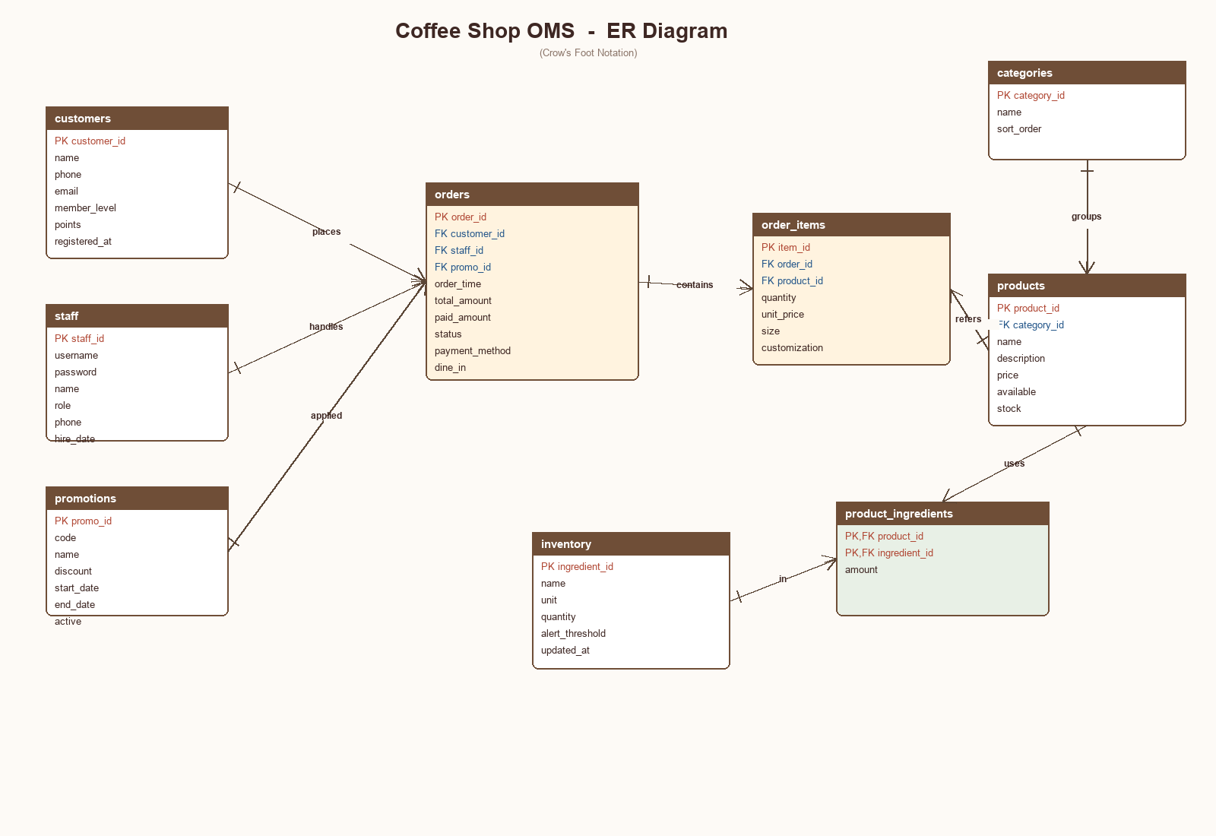
Figure 1. ER Diagram of the Coffee Shop OMS
3.3 Logical design (relations). The conceptual model is mapped to nine relations. Primary keys are underlined in the diagram and marked PK in the schema; foreign keys are marked FK.
- customers (customer_id PK, name, phone, email, member_level, points, registered_at)
- staff (staff_id PK, username, password, name, role, phone, hire_date, active)
- categories (category_id PK, name, sort_order)
- products (product_id PK, category_id FK, name, description, price, available, stock)
- promotions (promo_id PK, code, name, discount, start_date, end_date, active)
- orders (order_id PK, customer_id FK, staff_id FK, promo_id FK, order_time, total_amount, paid_amount, status, payment_method, dine_in, remark)
- order_items (item_id PK, order_id FK, product_id FK, quantity, unit_price, size, customization)
- inventory (ingredient_id PK, name, unit, quantity, alert_threshold, updated_at)
- product_ingredients (product_id PK/FK, ingredient_id PK/FK, amount)
3.4 Physical design (MySQL DDL). The full DDL is provided in sql/schema.sql. Excerpt:
CREATE TABLE orders (
order_id INT AUTO_INCREMENT PRIMARY KEY,
customer_id INT,
staff_id INT NOT NULL,
promo_id INT,
order_time DATETIME DEFAULT CURRENT_TIMESTAMP,
total_amount DECIMAL(10,2) NOT NULL DEFAULT 0,
status ENUM('PENDING','PAID','PREPARING','READY','COMPLETED','CANCELLED'),
payment_method ENUM('CASH','CARD','WECHAT','ALIPAY') DEFAULT 'WECHAT',
dine_in TINYINT(1) DEFAULT 1,
FOREIGN KEY (customer_id) REFERENCES customers(customer_id) ON DELETE SET NULL,
FOREIGN KEY (staff_id) REFERENCES staff(staff_id),
FOREIGN KEY (promo_id) REFERENCES promotions(promo_id) ON DELETE SET NULL,
INDEX idx_time(order_time), INDEX idx_status(status)
) ENGINE=InnoDB;
3.5 Constraints and business rules.
- Primary-key and foreign-key constraints guarantee entity and referential integrity.
- CHECK (quantity > 0) on order_items prevents zero / negative line items.
- ENUM types restrict status, role, payment_method to valid values.
- Unique indexes on customers.phone, staff.username, promotions.code prevent duplicates.
- Index on orders(order_time) and orders(status) accelerates the dashboard and filter queries.
3.6 Database programming. Three triggers and one stored procedure implement business rules inside the database:
-- Trigger 1: recompute order total whenever an item is inserted
CREATE TRIGGER trg_item_after_insert AFTER INSERT ON order_items
FOR EACH ROW
BEGIN
UPDATE orders SET total_amount = (
SELECT COALESCE(SUM(quantity * unit_price),0)
FROM order_items WHERE order_id = NEW.order_id
) WHERE order_id = NEW.order_id;
END;
-- Trigger 2: award loyalty points when an order becomes PAID
CREATE TRIGGER trg_order_after_update AFTER UPDATE ON orders
FOR EACH ROW
BEGIN
IF NEW.status = 'PAID' AND OLD.status <> 'PAID' AND NEW.customer_id IS NOT NULL THEN
UPDATE customers SET points = points + FLOOR(NEW.total_amount)
WHERE customer_id = NEW.customer_id;
END IF;
END;
-- Stored procedure: place a single-item order in one call
CREATE PROCEDURE sp_place_order(IN p_customer INT, IN p_staff INT,
IN p_product INT, IN p_qty INT,
OUT p_order_id INT) ...
3.7 Representative SQL queries used by the application:
-- (a) today's revenue
SELECT SUM(total_amount) FROM orders
WHERE DATE(order_time) = CURDATE() AND status <> 'CANCELLED';
-- (b) top-5 best-selling products
SELECT p.name, SUM(oi.quantity) AS qty
FROM order_items oi JOIN products p ON p.product_id = oi.product_id
GROUP BY p.product_id ORDER BY qty DESC LIMIT 5;
-- (c) ingredients below alert threshold
SELECT name, quantity, alert_threshold FROM inventory
WHERE quantity <= alert_threshold;
-- (d) members ranked by points
SELECT name, member_level, points FROM customers ORDER BY points DESC;
3.8 Sample DML used during testing:
INSERT INTO orders(customer_id, staff_id) VALUES (1, 3);
SET @o := LAST_INSERT_ID();
INSERT INTO order_items(order_id, product_id, quantity, unit_price)
VALUES (@o, 3, 2, 25.00), (@o, 11, 1, 32.00);
UPDATE orders SET status='PAID' WHERE order_id=@o;
-- trg_item_after_insert recomputes total_amount to 82.00
-- trg_order_after_update awards 82 loyalty points to customer 1
4. Brief Instructions for Use
4.1 Environment Prerequisites: Python 3.10+, MySQL 8.0+ (optional - SQLite is used by default and requires no installation). The dependencies are listed in src/requirements.txt and consist of Flask, Flask-SQLAlchemy and PyMySQL.
4.2 One-click Launch. The submission ships with two double-clickable launchers. On macOS, double-click `启动咖啡店系统.command`; on Windows, double-click `启动咖啡店系统.bat`. The script will check Python, create a local virtual environment on first run, install the dependencies and start the Flask development server on port 5050. A browser tab automatically opens to http://127.0.0.1:5050.
4.3 Manual Launch (MySQL mode):
mysql -uroot -p < sql/schema.sql
mysql -uroot -p coffee_shop < sql/data.sql
cd src && python app.py # http://127.0.0.1:5050
4.4 Demo accounts (pre-loaded by the bootstrap routine):
Role | Username | Password
Admin | admin | admin123
Barista | barista | barista123
Cashier | cashier | cashier123
4.5 Typical user workflow: Cashier opens 'New Order', picks the customer (or 'Walk-in'), adds menu items with size and quantity, chooses payment and submits. The Barista watches the 'Orders' page and updates status to PREPARING / READY / COMPLETED. The Admin manages menu items, inventory and reviews statistics.
5. Main Interface Screenshots
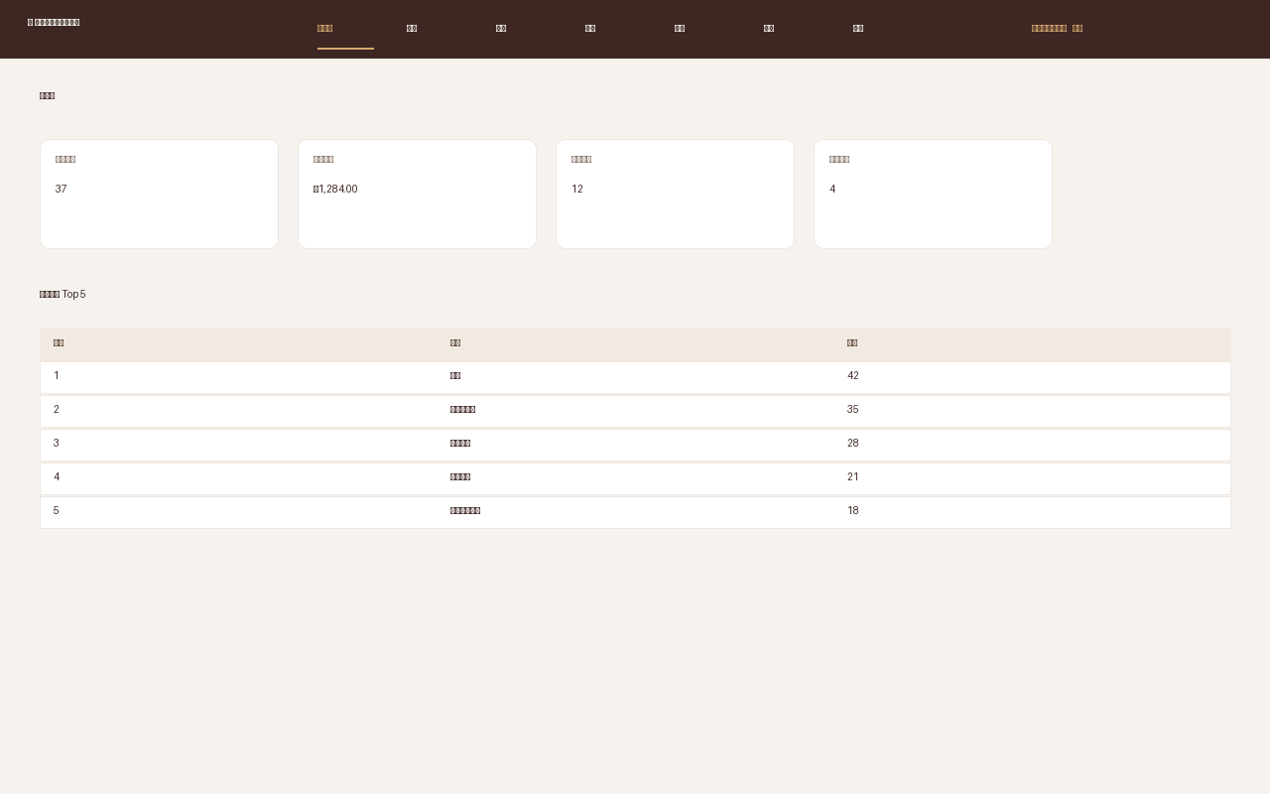
Figure 2. Dashboard - KPI cards and top-5 sellers.
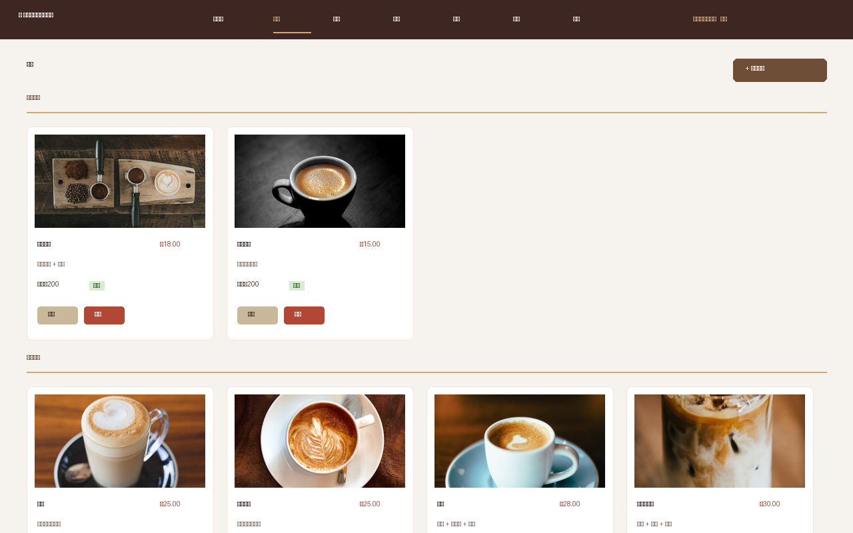
Figure 3. Menu - categorised product cards with admin actions.
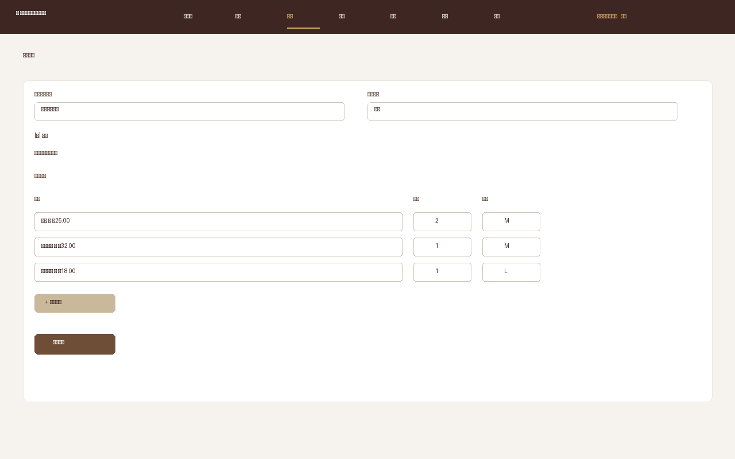
Figure 4. New Order - multi-line cart with size and payment.
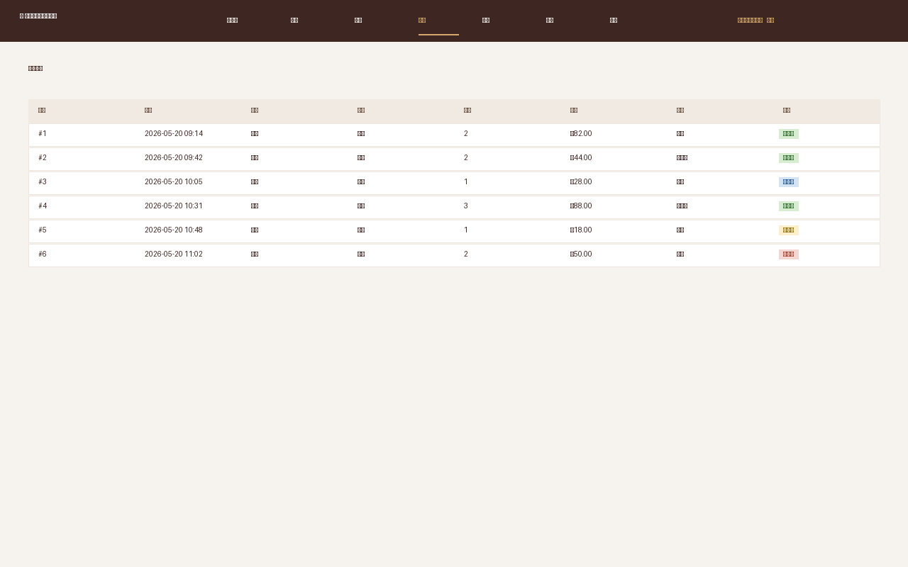
Figure 5. Order list - status filter and color tags.
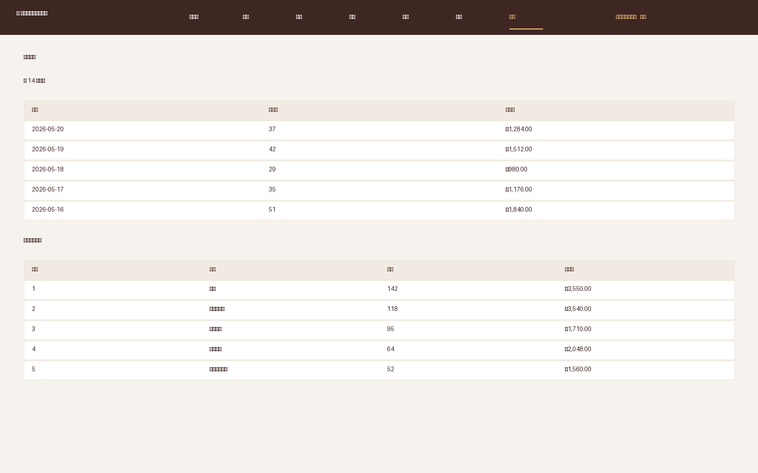
Figure 6. Statistics - daily revenue and product ranking.
6. Summary
6.1 What we accomplished. This course design delivered a fully working Coffee Shop Order Management System backed by MySQL and a Flask web application. From the database side, the project exercised the entire design lifecycle: requirement analysis, conceptual modelling with an ER diagram, logical mapping to 3NF relations, and physical implementation with DDL/DML, indexes, views, triggers and a stored procedure. From the application side, the system implements role-based authentication, complete CRUD on every entity, a multi-line order cart, an order-status state machine, ingredient inventory with low-stock alerts, and daily / per-product statistics.
6.2 Existing problems and future improvements: (1) Passwords are stored in plain text for grading convenience and should be replaced with salted hashes (werkzeug.security or bcrypt) before production use. (2) The system currently runs as a single Flask process; for higher concurrency it should be deployed behind Gunicorn + Nginx. (3) The inventory model only decrements ingredients on demand - an automatic deduction at the moment of payment, plus periodic stock-take reconciliation, would make the inventory module closer to reality. (4) Front-end styling is intentionally lightweight; a richer SPA (Vue / React) could improve UX, especially for the order-taking screen on tablets.
6.3 Learning outcomes. Through this project the team gained hands-on experience in translating a real business scenario into a normalised relational model, in using triggers / stored procedures to keep business invariants close to the data, and in building a complete data-driven web application end to end. The two-person collaboration also exercised Git-based version control, branch synchronisation, and code review skills that are essential for future industry work.
7. References
- [1] Abraham Silberschatz, Henry F. Korth, S. Sudarshan. Database System Concepts (7th Edition). McGraw-Hill, 2019.
- [2] Wang Shan, Sa Shixuan. An Introduction to Database Systems (5th Edition). Higher Education Press, 2014.
- [3] Oracle Corporation. MySQL 8.0 Reference Manual. https://dev.mysql.com/doc/refman/8.0/en/
- [4] Pallets Projects. Flask Documentation (3.x). https://flask.palletsprojects.com/
- [5] Mike Bayer. SQLAlchemy 2.0 Documentation. https://docs.sqlalchemy.org/
- [6] Martin Fowler. Patterns of Enterprise Application Architecture. Addison-Wesley, 2002.

